HOLCOMBE BURNELL
DEFIBRILLATOR

Further to the demonstration of the new defibrillator from Cardiac Science earlier this year, another session is planned by South West Ambulance Service.

This will cover what to do from making the 999 call through to using the defibrillator during a cardiac arrest incident. It is an AED type defibrillator as installed at other parishes including Tedburn St Mary, Whitestone and Ide.

Using the defibrillator to restart the heart after a heart attack, during what is sometimes called the golden half hour can save lives, so it is a really worthwhile training session.

All are welcome – no matter where you live…

There will be a talk/demonstration by
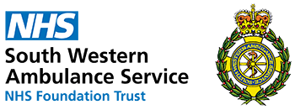

South West Ambulance Service
On Thursday September 26th September, 7.00 pm
At Longdown village hall.

Of course this is not for your need. It is for your neighbour, Mum, Dad, wife, husband and (perhaps) even your child, it for their need.
